Manual Depreciations
- Go to Financials > Fixed Assets > Manual Depreciations.
- Use this function when you don’t want to depreciate the planned amount in a specific period.
- Specify “Ordinary Depreciation” as Transaction Type.
- Specify the Posting Date, Document Date, and Asset Value Date.
- Specify the Asset which you wish to run manual depreciation and the amount to depreciate.
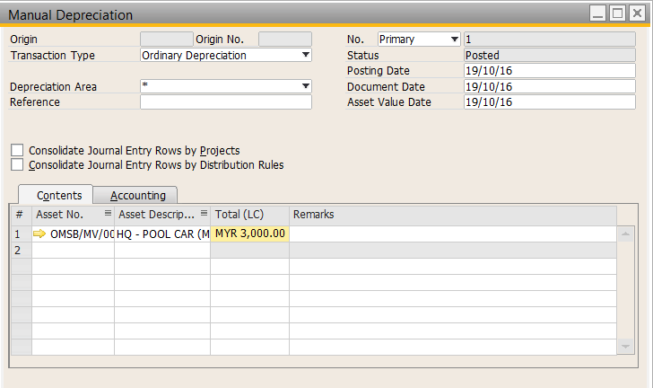

- The journal Entry after the document added as below.
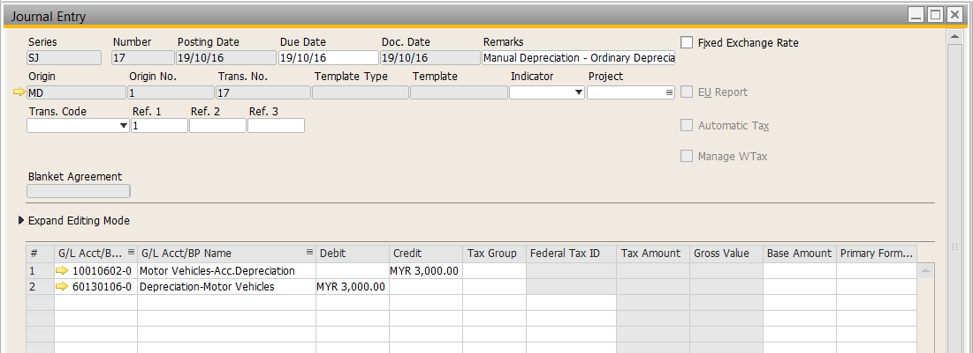

- In asset master data, Fixed Asset tab > Depreciation you will see


